# Problem statement and hypothesis

Using observations and measurements of solar activity (sun spots, solar flares, coronal mass ejections) can we predict geomagnetic activity on Earth?

My hypothesis is that the intensity of geomagnetic storms on Earth increases when solar activity prior to a major event such as a coronal mass ejection is elevated. If my hypothesis is correct, the strongest geomagnetic storms on Earth will be foreshadowed by a period of higher than mild solar activity culminating in a large burst of energy from the Sun.

# Description of your data set and how it was obtained

The data was obtained from the National Geophysical Data Center which records and aggregates information from several observatory stations on Earth. Satellite observations of solar activity are from NASA’s SOHO LASCO CME CATALOG. Both sources of information are in multiple .csv files.

The Selected Geomagnetic and Solar Activity Indices from the National Geophysical Data Center is located at this [url](ftp://ftp.ngdc.noaa.gov/STP/GEOMAGNETIC_DATA/INDICES/KP_AP/%23kp_ap.fmt%23) and the data dictionary is located [here](ftp://ftp.ngdc.noaa.gov/STP/GEOMAGNETIC_DATA/INDICES/KP_AP/%23kp_ap.fmt%23) There is one fixed width text file per year. The relevant data in the file is the **C9 field** which as cumulative measure of geomagnetic disturbance for the day. C9 = 0 is a very quiet day on Earth, C9 = 9 is an extremely active day. The **ISN field** is the International Sunspot Number and is a relative measure of the number of sunspots identified on the surface of the Sun on that day.

I later added another NGDC data set for daily solar activity located [here](ftp://ftp.swpc.noaa.gov/pub/warehouse/). There is an ftp folder for each year and a file called YYYY_DSD.text for the specific year. DSD stands for Dailey Solar Data. The relevant data in these files are the counts of x-ray flares by energy category: S, C, M, X. As well as optical flares by energy category: 1, 2, and 3.

In addition, I added another NGDC data set for daily solar particle activity located with the daily solar activity linked to above. The relevant data in these files are flux measurements, particles per square centimeter of proton flows at 3 different energy levels.

NASA’s SOHO LASCO CME catalog is located at this [url](http://cdaw.gsfc.nasa.gov/CME_list/UNIVERSAL/text_ver/). The file **univ_all.txt** contains the entire catalog and the data dictionary is located [here](http://cdaw.gsfc.nasa.gov/CME_list/catalog_description.htm). The relevant data in the file is the **Linear Speed** and **Speed at 20 Solar Radii**.

I also explored many catalogs of information in the hope of getting specific energy levels for the solar flare counts in the DSD files. SpaceWeatherLive.com has a fantastic searchable database but it was not suitable for downloading a series of events. I reached out the site admin and received a reply pointing me back to the NGDC data. I’m still looking for the correct files for this information.

# Description of any pre-processing steps you took

All data sets are in a fixed file format with footnote indicators embedded in the data. It was necessary to separate out those indicators into separate fields for interpretation.

The file formats for the NGDC DSD data were consistent except for the number of header rows at the top of the files. For some years there was an extra header row. Rather than building a routine to catalog which had the extra rows, I made a local copy of the data and deleted the extra row. For years 2014 and 2015, the headers were repeated in the body of the file and I removed them from my local copies. For years 1995 and 1996, the date format started out as DD MMM YY but in the later files the format is YYYY MM DD. Rather than deal with both formats, I omitted using 1995 and 1996.

The solar indices data is compete except for the ISN numbers for 2015, so I omitted that year from the analysis.

The NASA’s SOHO LASCO CME catalog has a number of data issues in terms of missing data and data flagged as unreliable. I focused my attention on the fields where the quality was not in question. One adjustment I needed to make to this data was to aggregate multiple measurements for a single day. So that it can be matched to the daily geomagnetic and solar indices from the other data sets. I used the maximum value of Linear Speed and Speed at 20 solar radii as the aggregation value. My thinking here is that the dominant effect would be by the largest CME for that day. In the cases where there were no CME’s on that day, I set the speeds to 0.

The most complex part of the pre-processing involves summarizing prior history and adding it as features to each row. For example, I wanted to get a count of solar flares of a certain type over the past week and add it as feature for that day. In addition, I wanted to know if prior C9 values was a good predictor of the current value. I used the .shift method on the datetime index to shift the data by n days and then appending the features of interest to my dataset. For example, after shifting the date by 1 day all the measurements for 12-31-13 are now associated with 1-1-14 in a new dataframe, I can then join the dataframes on date and pick up the historical features. Pretty slick! I also added some code to summarize some feature over a historical date range (e.g. the prior week leading up to that day) and add it using the technique above.

# What you learned from exploring the data, including visualizations

Some expected patterns are present in the data. For example, our sun is on an 11 year solar cycle where the number of sunspots displays a minimum and maximum over this period.

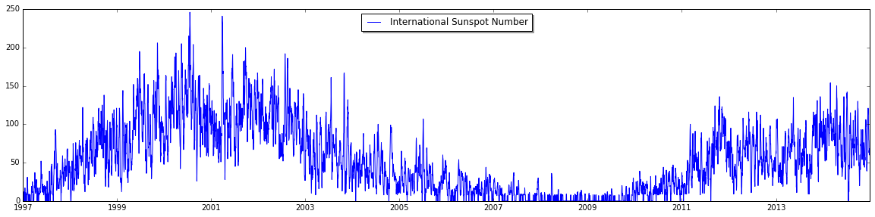

The occurrence of solar flares follows a similar pattern as expected

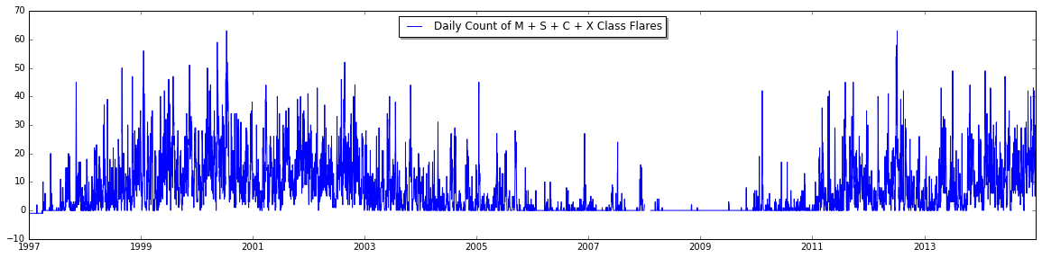

However, the occurrence of extreme geomagnetic activity on the Earth is a bit less regular

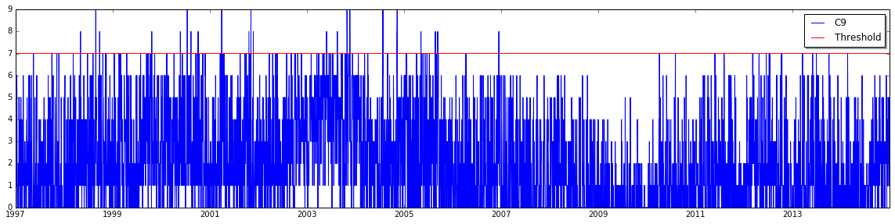

The points above the red threshold line are the extreme events of particular interest for this analysis

In addition, the pattern of CME’s observed during this period was different with some of the most active years later in the graph, but the most extreme geomagnetic days in the earlier years.

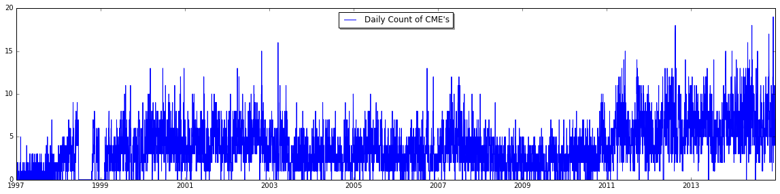

It was clear from the simple visualizations that the relationship between events on the sun and those on the Earth is not a simple relationship.

# How you chose which features to use in your analysis

Initially, I chose features that show some initial correlation to the C9 (geomagnetic activity) data: International Sunspot Number and Solar Flare Counts. I also used the CME data thinking that it must have some correlation to since some solar flares are also accompanied by a CME.

# Details of your modeling process, including how you selected your models and validated them

Link to the Jupyter notebook analysis is in this [script](https://github.com/wayneheller/GA-Student-Project/blob/master/ipythonscripts/Intial_Analysis_Cp_and_CME.ipynb). It has all the analysis leading up the Kmeans clustering. I created a second notebook for the logistic regression model [here](https://github.com/wayneheller/GA-Student-Project/blob/master/ipythonscripts/Second_Analysis.ipynb). I will probably combine these two at some point.

I first chose a logistic regression model with the expectation of finding some predictive relationship between the features and the C9 data. I quickly realized that the extreme (C9 >= 8) events are rare. Only 28 over the last 17 years and that I probably have not identified all the necessary features to make an accurate prediction. I was also trying to match a single event on the Sun with an extreme geomagnetic day on the Earth. Reflecting on the problem, I updated my hypothesis to look at 1 week’s history prior to an extreme event, and to try to build a clustering model to hopefully categorize these events.

I chose a Kmeans model to start, given its simplicity to implement and measure accuracy. I analyzed 16 combinations of features to group these events in 5 clusters using the individual sums of S, C, M, X x-ray flares and Opt3 optical flares with a silhouette coefficient of .513

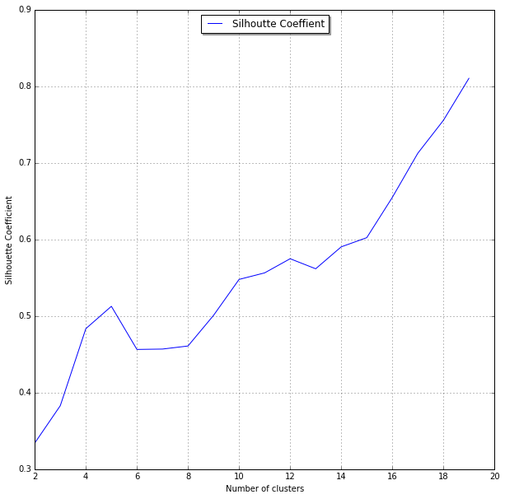

Based on this summary of result features it appears that the Proton flux counts would be good predictor of the C9=9 days

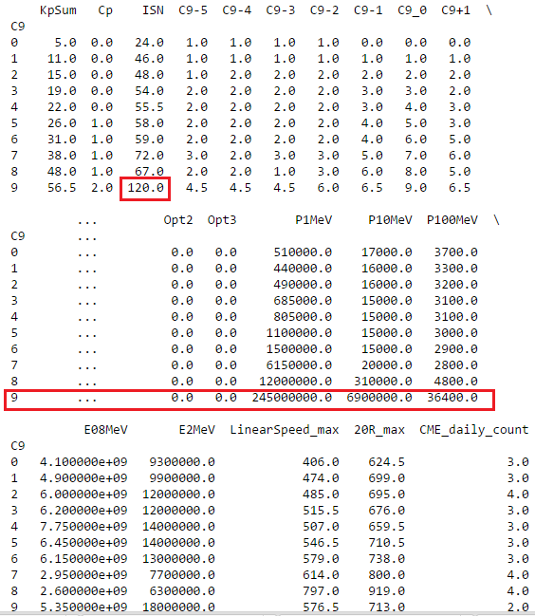

Below are the results of running a Logistic Regression model on Proton flux counts at 10MeV and 100MeV (the features) and C9=9 (response). It turns out that adding ISN as a feature diminishes the results.

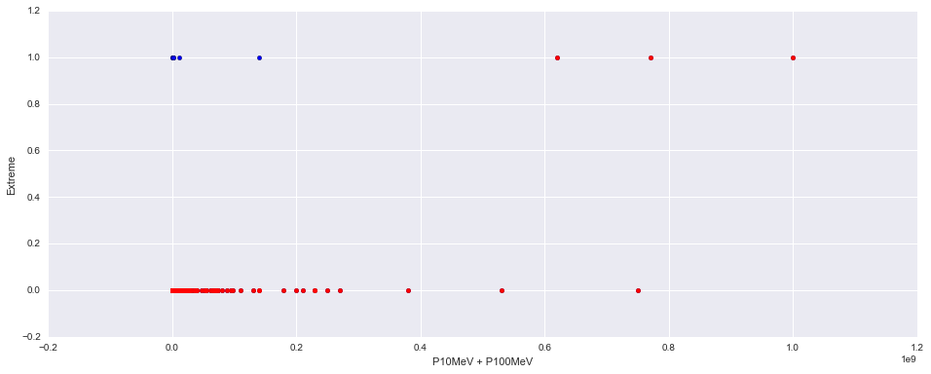

Below is the associated ROC curve with a score of .980. Despite the high score, this is not a good predictive model for the extreme whether days due to the large number of false positives. Out of the 10 extreme C9=9 days, the model only predicted 3 of them. Most of its predictive power is in predicting majority of the events C9<9.

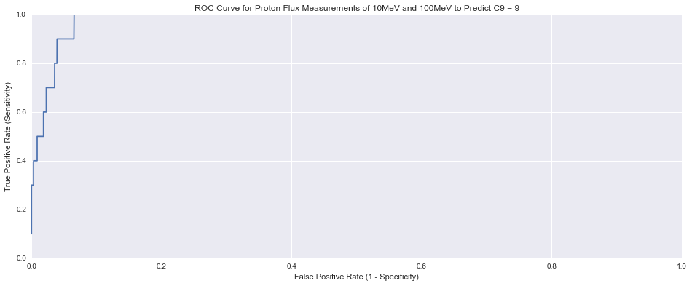

# Your challenges and successes

Biggest recent challenge was finding the right catalog of information on the solar flares

Because the response vector for the C9=9 events is so small compared to the overall dataset, I’m having a challenging time finding the right predictive model.

# Possible extensions or business applications of your project

I’ve read a couple of papers describing the use of neural networks for the prediction of sunspots but it seems like the use of these predictive techniques in this field is just emerging.

# Conclusions and key learnings